# Teaching and Mentoring (8%)

1. **Summary**

Dr. **** is actively involved in education and mentoring of learners at all levels, including undergraduate students, medical students, residents, fellows and faculty. Dr. ****’s educational efforts include clinical and bedside teaching, didactic lectures, and trainee mentoring. Dr. **** also has served on or chaired 11 Department of Pediatrics Faculty Mentoring Committees. These mentoring committees provide junior faculty with support, advice, and counseling to ensure that mentees advance in their chosen academic pathway. Dr. **** has served as resident advisor for Pediatrics residents, providing career mentoring advice and ensuring that each of her advisees fulfills all academic and clinical residency requirements. Dr. **** is also committed to mentoring students/residents and fellows interested in pursuing research projects and/or fellowship training. Her contributions as an Allergy/Immunology research mentor have led to the advancement of high-quality fellow applicants who have secured fellowship positions in excellent training programs with 9 of Dr. ****’s former mentees securing positions as Allergy/Immunology faculty at academic institutions upon completion of fellowship training. In addition to institutional teaching/mentoring responsibilities, Dr. **** has also been an invited lecturer, panelist and moderator on both the regional and national level. Dr. ****’s excellence in teaching and mentoring has been recognized by receiving the Red Sash Award multiple times, UAMS Department of Pediatrics Educator of the Year Award in 2017 and the Joan Cranmer Mentor of the Year Award in 2019. Dr. **** has also contributed toward scholarly activity within the UAMS DOP Faculty Mentoring Program by serving on the core writing group for the DOP Faculty Mentoring Program publication in *Pediatrics*.

# Trainee Education

Dr. **** contributes to the education of learners at all levels by conducting bedside teaching rounds for inpatient and outpatient consultative services in Allergy/Immunology and clerkship lectures to students/residents/fellows rotating on the A/I service. Her clinical teaching evaluations scores have all been above the overall faculty scores (sample clinical teaching scores and comments are provided below). Dr. **** also participates in Didactic Teaching as a lecturer in the Medical Microbiology and Immunology Disease and Defense Medical Student Course, as an annual lecturer for the Intern Lecture series and lecturer for resident noon conference series. She is also one of the ACGME Core Faculty Members for the Pediatric Residency Program and has served on the Clinical Competency Committee. She has been a key curriculum advisor and core faculty member for the Allergy/Immunology Fellowship Program, with the first Allergy/Immunology Fellow starting in July 2021.

* 1. Medical Students
     1. Medical Student Microbiology/Immunology Disease and Defense Course
     2. Junior Medical Students: Allergy/Immunology/Asthma Inpatient Attending, Allergy/Immunology Clinics, Allergy/Immunology Core Lectures
     3. Senior Medical Students: Allergy/Immunology/Asthma Inpatient Attending, Allergy/Immunology Clinics, Core Faculty and Curriculum Committee for Senior Culinary Medicine Elective
  2. Residents: Allergy/Immunology/Asthma Inpatient Attending, Allergy/Immunology Clinics, Resident Advisor, ACGME Core Faculty, Clinical Competency Committee, Research Mentor, Pediatric Lecture Series
  3. Fellows: Scholarship Oversight Committee, Fellows’ Research Day, Core Faculty/Curriculum Advisor for New Allergy/Immunology Fellowship Program (1st Fellow July 2021)

# Clinical Teaching and Lecture Evaluations:

Dr. **** is consistently ranked highly for her clinical teaching and lectures. Representative teaching evaluations with comparisons to Department of Pediatrics averages are listed below. In addition, a representative evaluation from the Microbiology and Immunology Disease and Defense Course is included highlighting Dr. ****’s performance above the course faculty average.

Representative comments are also included.

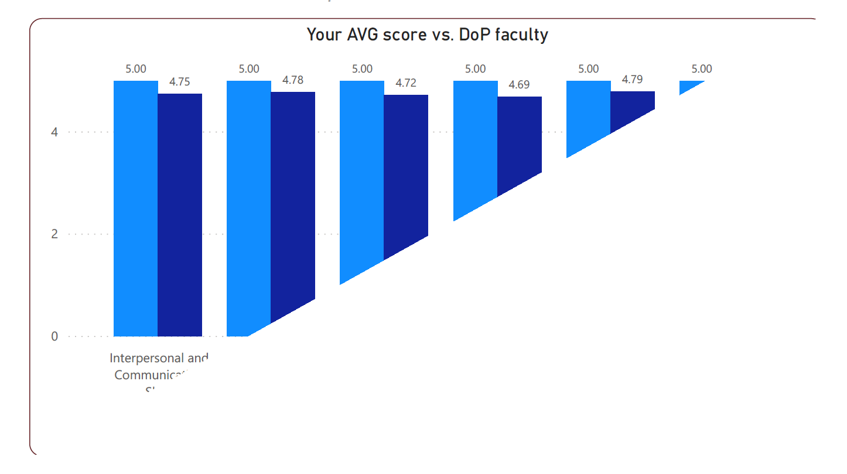

## Sample Comments from Dr. ****’s Teaching Evaluations:

“Absolute pleasure to work with. Very knowledgeable and great teacher, excellent bedside manner- a true role model physician.”

“Dr. **** made clinic very enjoyable. She was an active teacher and really allowed us to take ownership of our patients. She is always so much fun to work with and really wants to make the resident experience great.”

“I thoroughly enjoyed working with Dr. ****. I appreciate the time she takes to teach while seeing patients. She does a wonderful job of explaining things to families.”

“I really enjoyed working with Dr. **** during my A/I month. She is so sweet and encouraging even in difficult patient situations. Her passion and love for her work is quite evident in her daily clinical duties but also in how she consistently took time out of clinic to make sure residents and students were getting the necessary learning. Overall excellent physician.”

“I only had the opportunity to work with Dr. **** 1 morning during my rotation, but I love her! I have also worked with her on the inpatient side as an intern and she is a great teacher! She is very personable and easy to approach with silly questions. She is very enthusiastic and has a great positive attitude. She is very enjoyable to work with.”

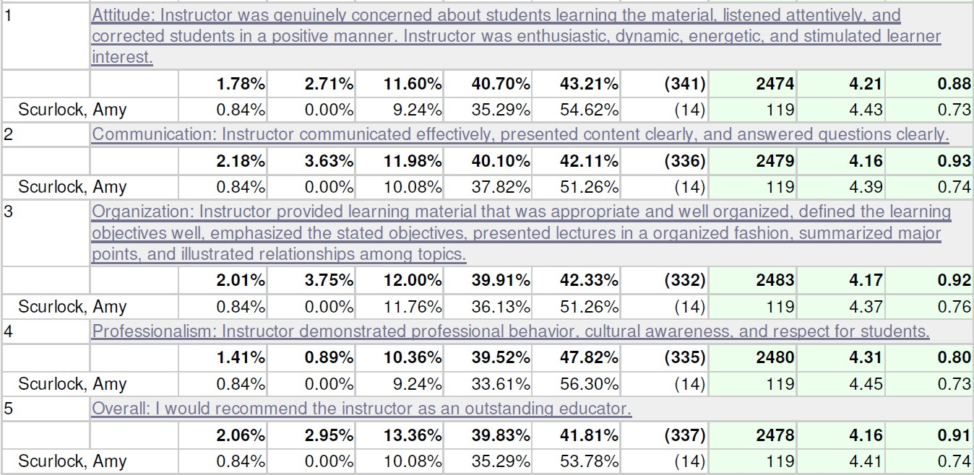

## Sample Comments from Dr. ****’s Lecture Evaluations:

“Dr. **** was a wonderful lecturer! Her material was organized extremely well, and her presentation and her communication were both very clear. As a side note, she was also very positive and motivating, and I felt inspired by her. Thanks!”

“I loved Dr. ****’s lecture on immune disorders. It was obvious that she really cares about her patients and she wants us to do the same.”

“Dr. ****’s lecture was fantastic! She presented a lot of important, high yield information in an extremely efficient way! She even answered may good questions and still managed to only run five minutes over schedule! On top of that her lecture was very inspirational (especially in a subject for which I previously had a lot less interest).”

“Loved Dr. ****’s lecture!! She was amazing! Her PowerPoint setup was awesome (loved the case presentation to teach disorders) and it really helped for learning. Would love for her to teach us everything! Engaging, passionate, and easy to tell she cares for her patients. Wonderful example of a good doctor.”

“This was my favorite lecturer of the entire course, if not the year! All the material she presented was presented within clinical scenarios. The material was extremely well-organized. She was passionate about what she was teaching us and inspired interest from me in this subject. I learned a great deal from her lecture on the first run through the material because of her method of teaching. I hope to hear more from her again in the future.”

# Mentoring Activities

Dr. **** has served as mentor for individuals at all levels of education from undergraduate to junior faculty (see below). She has served on or chaired 11 Department of Pediatrics Mentoring Committees. She has mentored 12 residents by serving as their residency advisor for UAMS Pediatrics and Internal Medicine-Pediatrics residency programs and served as research/QI advisor for 23 UAMS residents.

She has served on 4 Pediatric Fellows Scholarship Oversight Committees, in addition to mentoring an MPH student and serving on a Graduate Student Dissertation Committee. She has been an undergraduate student mentor to 15 students. Dr. ****’s mentees have published peer-reviewed manuscripts, presented at regional and national research conferences, and successfully completed

their respective training programs in health-related undergraduate/graduate, medical degree and fellowship programs.

Faculty Mentoring Committees (UAMS Department of Pediatrics):

1. XXXX, M.D., MSCS (Clinician Educator- Hematology/Oncology)- Committee Chair, Promoted to Associate Professor with Tenure 7/2015
2. XXXX, M.D. (Clinician Educator-Neonatology)- Member, Promoted to Associate Professor, NTE (part-time appointment)
3. XXXX, M.D. (Clinical Attending, General Pediatrics/Neonatology)-Member, Promoted to Associate Professor
4. XXXX, M.D. (Clinical Educator, Cardiology)-Member, Promoted to Associate Professor
5. XXXX, M.D. (Clinician Educator, Neonatology)-Member
6. XXXX, M.D. (Clinician Educator, Neonatology)-Chair
7. XXXX, M.D. (Clinician Educator, Adolescent Medicine)-Chair, Promoted to Associate Professor with Tenure, 7/2019
8. XXXX, M.D. (Clinician Educator, Hematology-Oncology)-Member
9. XXXX, M.D. (Clinician Educator, Pediatric Hospital Medicine)- Member
10. XXXX, M.D. (Clinician Educator, Pediatric Critical Care Medicine)- Chair
11. XXXX, M.D. (Clinician Educator, Pediatric Critical Care Medicine)-Member

Pediatric Fellow Scholarship Oversight Committee:

* 1. XXXX, M.D.- 1/2011- 6/2013 (Critical Care Medicine Fellow)
  2. XXXX, M.D.-7/2013-6/2015 (Critical Care Medicine Fellow)
  3. XXXX, M.D.- 7/2014-6/2017 (Pulmonary Fellow)
  4. XXXX, M.D. – 7/1/2018- 6/2021 (Critical Care Medicine Fellow)

College of Public Health, Masters of Public Health, Integration Project Mentor:

1. XXXX, Ph.D.- 6/2011-2012 “Clinical Features Predicting Primary Immunodeficiency Diseases

Student Research Mentor:

1. XXXX, 2005, (Summer Science Program) “Persistence of Chlamydia trachomatis in the Female Gastrointestinal Tract”
2. XXXX, 2006, (Medical Student Research Rotation) “Persistence of Chlamydia trachomatis in the Female Gastrointestinal Tract”
3. XXXX, 2006, (Summer Science Program) “Chlamydial Persistence in High Risk Adolescent Females”
4. XXXX, 2006 (Arkansas Commitment Program) “Developing a Murine Model of Gastrointestinal Chlamydial Persistence”
5. XXXX, 2007 (UAMS College of Medicine Honors Program) “Immunopathology Following Chlamydia Trachomatis Genital Tract Infection”
6. XXXX, 2007, (Summer Science Program) “Immunopathogenesis of Chlamydia Trachomatis Infection”
7. XXXX, 2007, (Undergraduate Student Research Rotation) “Immunopathogenesis of Chlamydia Trachomatis Infection”
8. XXXX, 2009, (Summer Science Program) “Diagnosing Pelvic Inflammatory Disease in Outpatient Settings: A Review of Symptoms, Examination and Treatment”- Collaborative project with Dr. Jennifer Woods and ACH Adolescent Center
9. XXXX, 2010 (Undergraduate Student Research Project) “Immunoregulatory Networks in Chlamydia Genital Tract Infection”
10. XXXX, 2012 (UA), (Summer Science Program) “Understanding the effects of acetaminophen on small airways in human precision cut lung slices”
11. XXXX, 2012 (UCA), (Summer Science Program) “The role of innate immunity in sensitization to peanut allergy”
12. XXXX 2013 (UA), Summer Science Program, “The role of food insecurity among families of food allergic children.”
13. XXXX 2013 (UALR), Summer Science Program, “The role of innate immunity in the development of peanut allergy.”
14. XXXX 2015 (UA), Summer Science Program, “Walnut OIT for Tree Nut Allergic Children”
15. XXXX 2020 (UA), Summer Science Program, “Anxiety, Depression and Resilience Among Food-Allergic Adolescents and Caregivers during the COVID-19 Pandemic”

Graduate Student Dissertation Committee

1. XXXX (Ph.D. Interdisciplinary Biosciences Program, UAMS) 2012-2015

UAMS Medical Student Honors in Research Mentor:

* 1. XXXX, 2007-2010; *Completed UAMS Urology Residency 6/2015; Urologist, Logan Health, Kalispell, MT*
  2. XXXX, 2021-present Pediatric Resident Advisor:

1. XXXX, M.D.- 7/2006- 6/2007

* + - *Pediatrics, Baylor College of Medicine, Houston, TX*

2. XXXX, M.D.- 7/2006- 6/2009

* + - *Pediatrics, ARCare, Heber Springs, AR*

3. XXXX, M.D.- 7/2007 -12/2007

* + - *Allergy/Immunology Faculty, UAMS/Arkansas Children’s, Little Rock, AR*

4. XXXX, M.D.- 7/2007 -6/2010

* + - *Pediatrics, MANA/Northwest Arkansas Pediatrics, Fayetteville, AR*

5. XXXX, M.D.-7/2009-6/2012

* + - *Pediatrics, CHI St. Vincent, Hot Springs, AR*

6. XXXX, M.D.- 7/2010 to 6/2013

* + - *Pediatrics, Arkansas Pediatric Clinic, Little Rock, AR*

1. XXXX, M.D.- 7/2011-6/2014
   * *Allergy/Immunology, Arkansas Otolaryngology, Little Rock, AR*

8. XXXX, M.D.- 7/2012-6/2015

* + *Pediatric Gastroenterology, Gulfport, MS*

1. XXXX, M.D.-7/2013-2016
   * *General Pediatrics, Little Rock, AR*

10. XXXX, M.D.- 7/2014-2017

* + *Critical Care Medicine, Arkansas Children’s, Little Rock, AR*

11. XXXX, M.D.- 7/2015-2018

* + *Endocrinology Faculty, UAMS/Arkansas Children’s, Little Rock, AR*

12. XXXX, M.D.- 7/2016-2019

* + *Pediatrics, Community Clinic, Rogers, AR*

Pediatric Resident Research/QI Mentor:

1. *XX, MD, Resident Physician; 2004-2006
2. XX, DO, Resident Physician; 2005-2006
3. XX, MD, Resident Physician; 2004-2006
4. *XX, MD, Resident Physician, 2007-2008
5. **XX, MD, Resident Physician, 2007-2008
6. *XX, MD, Resident Physician; 2007-2008
7. XX, MD, Resident Physician; 2007-2008
8. *XX, MD, Resident Physician; 2007-2009
9. XX, MD, Resident Physician; 2008-2009
10. *XX, Resident Physician; 2009-2010
11. XX, MD, Resident Physician; 2008-2010
12. *XX, MD, Resident Physician; 2008-2011
13. *XX, MD, Resident Physician; 2008-2010
14. *XX, MD, Resident Physician, 2010-2012
15. *XX, MD, Resident Physician 2010-2013
16. *XX, DO, Resident Physician 2011-2013
17. *XX, M.D., Resident Physician, 7/2011-2014
18. *XX, M.D., Resident Physician, 7/2011-2014
19. *XX, M.D., Resident Physician, 7/2014-2017
20. *XX, M.D., Resident Physician, 2016-2018
21. *XX, M.D., Resident Physician, 2019-2021
22. *XX, M.D., Resident Physician, 2020-2021
23. XX, MD, Resident Physician, 2020-2021

*\*Pursuing or completed fellowship in Allergy and Immunology*

\*\**Completed fellowship in Rheumatology*

|  |  |
| --- | --- |
| **Table 1. Academic Accomplishments of Dr. ****’s Research Mentees** | |
| Academic Faculty Appointment in A/I | 9 |
| Completed Allergy Immunology Fellowship | 15 |
| Completed Rheumatology Fellowship | 1 |
| Published peer-reviewed manuscript | 10 |
| Presentations at national/international research meeting | 12 |
| Presentations at regional research meeting | 16 |

|  |  |
| --- | --- |
| **Table 2. Academic Allergy/Immunology Appointments of Dr. ****’s Mentees** | |
| XX, MD | University of Arkansas for Medical Sciences Associate Professor |
| XX, MD | Indiana University School of Medicine Associate Professor |
| XX, MD | University of Arkansas for Medical Sciences Clinical Attending |
| XX, MD | University of Arkansas for Medical Sciences Associate Professor |
| XX, DO | University of Arkansas for Medical Sciences Assistant Professor |

|  |  |
| --- | --- |
| XX, MD | Baylor College of Medicine Assistant Professor |
| XX, MD | University of North Carolina Assistant Professor |
| XX, MD | University of Arkansas for Medical Sciences Assistant Professor |
| XX, MD | University of Tennessee Health Science Center LeBonheur Children’s Hospital  Assistant Professor |

# Faculty/Community/National Education

Dr. **** has been an invited speaker, panelist or session moderator at the local, regional and national level. Nine of these speaking engagements have provided continuing medical education (CME) credit for healthcare professionals.

# National Presentations:

1. AAAAI Annual Meeting, Primary Moderator, “Oral Immunotherapy for Food Allergy”, March 2,2014.
2. Mt. Sinai School of Medicine, Allergy Immunology Grand Rounds, “Food Allergy: Work in Progress, Bench and Bedside,” September 19, 2014.
3. Primary Moderator, Oral Abstract Session: “Peanut Oral Immunotherapy” AAAAI Annual Meeting, February 20-24,2015, Houston, TX.
4. Workshop Faculty: “Safety and Long-Term Outcomes of Baked Milk Diet vs. Milk OIT vs. Milk EPIT vs. Milk SLIT” in Allied Health: Strategies for Inducing Tolerance in Food Allergy, AAAAI Annual Meeting, March 3-6, 2017, Atlanta, GA
5. Workshop Faculty: Oral Food Challenges II: Hands-On Training Station AAAAI 2019 Annual Meeting February 22-25, 2019, San Francisco, CA
6. Fellow-In-Training Course: Career Paths in Allergy and Immunology. Academia- Clinical. AAAAI 2019 Annual Meeting February 22-25, 2019, San Francisco, CA
7. *Course Faculty, Primary Speaker: Food Allergy: Current Challenges and Future Directions, “Identifying Patients and Assessing Risks”, AAAAI 2020 Annual Meeting, March 13-16,2020 Philadelphia, PA
8. *Faculty, Fellow-In-Training Course: Career Paths in Allergy and Immunology. Academia- Clinical. AAAAI 2020 Annual Meeting March 13-16, 2020, Philadelphia PA
9. *Workshop Faculty: Oral Food Challenges: Hands-On Training Station AAAAI 2020 Annual Meeting March 13-16, 2020 *\* in-person meeting cancelled due to COVID-19 pandemic*
10. Food Allergy Research and Education (FARE) Speaker Series “20 in 2020”- Online presentation and interview by Nurry Hong, targeting 20 key thought leaders and stakeholders in food allergy, August 27, 2020
11. FARE Contains Courage® Research Retreat, “Immunotherapeutic Approaches for Treatment of Food Allergy”, Session Presenter, September 21-22,2020
12. FARE Contains Courage® Research Retreat, Panel Discussion Moderator, “Food Allergy Immunotherapy”, September 21-22, 2020
13. Course Faculty, Primary Speaker: Food Allergy: Current Challenges and Future Directions, “Identifying Patients and Assessing Risks”, AAAAI 2021 Virtual Annual Meeting, February 26- March 1, 2021
14. Faculty, Fellow-In-Training Course: Career Paths in Allergy and Immunology. Academia- Clinical. Invitation accepted for AAAAI 2022 Annual Meeting February 25-28,2022, Phoenix, AZ.

# Local/Regional Presentations:

1. UAMS DOP Faculty Development Seminar, “The Struggle with the Juggle: Seeking Balance in Life and Medicine”, April 2, 2013
2. Immune Deficiency Foundation, Outreach Program, “Newborn Screening for SCID/T-cell Lymphopenia in Arkansas”, April 6, 2013
3. Pediatric Resident Teaching Conference- “Choosing a Career in Academic Medicine”-April 29, 2013
4. AHEC Jonesboro, “Food Allergy”, June 4, 2013
5. UAMS Faculty Development Conference, “Balance vs. Burnout? Lessons Learned in the Quest for Work-Life Balance”, November 7, 2013
6. Faculty Development Seminar Series, “The Pediatrics Faculty Mentoring Program: How it Works for Successful Promotion”, November 18, 2014.
7. Faculty Development Seminar Series, “Working Parents: Making it Work?” February 3, 2015.
8. Lifequest of Arkansas, Healthcare Topics from Generation to Generation, “Food Allergy”, October 9, 2019, Little Rock, AR.
9. UAMS Department of Pediatrics Fellows’ Conference: “Work-Life Integration: Learning When to Say Yes and How to Say No”, September 13, 2021