### Patient Care (32%)

1. **Summary**

Dr. **** has been actively engaged in direct patient care and related clinical service, currently spending 32% of her time on clinical endeavors. She is a clinical and teaching attending physician for both inpatient and outpatient services providing care for patients with diseases of the immune system including environmental allergies, food allergies, drug/venom allergies, asthma, atopic dermatitis, eosinophilic disorders and primary immunodeficiency. Dr. **** is committed to providing all patients and families with state-of-the-art, family and patient-centered care; she has also been a committed advocate for advancing health in Arkansas and beyond, including playing an instrumental role in public health and legislative advocacy resulting in the addition of statewide newborn screening for Severe Combined Immune Deficiency (SCID) and disorders of T-cell Lymphopenia to the Arkansas Newborn Screening Panel. In addition, Dr. **** is the Medical Director of the Arkansas Children’s Immunology Clinic and Newborn Screening Follow-up Program. Dr. **** currently serves as a clinical liaison to the Arkansas Children’s Special Immunology Laboratory, providing input and advice on immunologic assays performed in the lab, with particular expertise in flow cytometry.

Dr. **** is a nationally recognized expert in diagnosis and management of food allergy and related disorders. She has been involved in the investigation of novel therapeutic approaches for food allergy for her entire career, and this work has informed her contributions to the development and implementation of the clinical oral immunotherapy (OIT) program for food allergy following FDA approval of Palforzia® (peanut OIT) for use in clinical practice. She is also the Principal Investigator and Director for the Food Allergy Research and Education (FARE) Clinical Network Discovery Center of Distinction at Arkansas Children’s, which allows for implementation of state-of-the-art, evidence-based protocols and resources through the FARE Clinical Network to improve care for patients and families burdened by food allergy. These resources include access to a patient care registry, patient and family educational resources and network support, and access to innovative research and novel therapies for food allergic individuals.

### Current Clinical Care Allotment:

* 1. Inpatient Allergy/Immunology Service: 8 weeks per year
  2. Inpatient Asthma Service: 4 weeks per year
  3. Inpatient Rheumatology Service: 3 weeks over the past year to assist with staff shortage
  4. Outpatient clinics:
     1. Arkansas Children’s Allergy Clinic (3-4 days/ mo.)
     2. Arkansas Children’s Immunology Clinic (2- 1/2 days/ mo.)
     3. Arkansas Children’s Northwest (ACNW) Immunology Clinic – 1-2 per year
  5. Medical Director, Arkansas Children’s Immunology Clinic and Newborn Screening Follow- Up Program
  6. Arkansas Department of Health (ADH) Newborn Screening Follow-up Program Clinical Liaison
  7. Clinical Consultant and Liaison: Arkansas Children’s Special Immunology Laboratory

### Specialized Clinical Service Provided by Dr. ****

* 1. **State of the Art Clinical Care for Food Allergy**

The Allergy and Immunology Service at Arkansas Children’s Hospital serves as a referral center for a seven-state region (AR, MS, LA, TN, TX, OK, MO) for children with food allergy. Dr. **** is nationally and regionally recognized for her clinical and research expertise in food allergy. The services provided by Dr. **** include diagnostic evaluations and allergy testing in the clinic setting as well as oral food challenges in the outpatient Allergy/Immunology Clinic and Pediatric Clinical Research Unit. Dr. **** and colleagues conduct approximately 250-300 oral food

challenges per year and serve as consultants for diagnosis and treatment of food allergy to a variety of patients, primary care physicians, and referring allergists. Dr. **** offers state-of-the-art clinical care and provides opportunity for involvement in cutting-edge research related to new immunotherapeutics as well as providing ongoing education and advocacy for her patients. Coordination of care of patients with food allergy is often complex and requires collaboration with multiple other services including Nutrition, Psychology, Psychiatry, Social Work, Gastroenterology, Otolaryngology, Primary Care Providers and others. Dr. **** is the Principal Investigator and Director of the FARE Clinical Network Discovery Center of Distinction at Arkansas Children’s which provides access, advocacy, education, and support for individuals and families with food allergy.

### Primary Immunodeficiency Disorders

Dr. **** provides medical services for both children and adults with primary immunodeficiency disorders. Primary Immunodeficiency Disorders are rare (affecting 1:1,000 to 1:106 individuals) and require specialized training within the field of Allergy and Immunology to effectively manage these complex disorders with multiple co- morbidities. Dr. **** and other faculty of the Allergy/Immunology service provide collaborative care to ~300 primary immunodeficiency patients from seven states.

Approximately 50 patients per month are treated in the Arkansas Children’s Infusion Center with intravenous immunoglobulin (IVIG) and/or other biologic immunomodulatory therapies. A host of others are managed through home health services to provide subcutaneous immunoglobulin replacement and biological therapies. Dr. **** has also been integrally involved in the diagnostic evaluation and management of complex, critically ill patients in the intensive care units (CVICU, PICU, NICU) and inpatient services at ACH. In addition to the state-of-the-art clinical care through diagnostic services and long-term management, Dr. **** is responsible for coordinating referrals to immunodeficiency transplant centers across the country for patients in need of bone marrow, stem cell, or thymic transplant. Dr. **** works collaboratively with colleagues in genetics and is integrally involved in the molecular genetics diagnoses of many patients that occur both in utero and ex utero as part of their primary immunodeficiency disease management. Management of these complex conditions requires coordinated care with multiple clinical services

and diagnostic centers, as well as comprehensive education for patients and families.

### Newborn Screening for Primary Immunodeficiency

During Dr. ****’s Fellowship Training at **** University, her primary mentor, Dr. **** repeatedly emphasized that “SCID is a pediatric emergency” and that newborn screening is critical to improve survival rates and decrease the time from diagnosis to transplant. Dr. **** was instrumental in advocating at the Arkansas Legislature for changes to the language of state law to not only allow for addition of Newborn Screening for Primary Immunodeficiency (SCID and Disorders of T-cell Lymphopenia), but also to pave the way for addition of future newborn screening modalities without requiring additional legislative changes. She has partnered with the Arkansas Department of Health (ADH) and Arkansas Public Health Laboratory (APHL) to develop protocols and practices for implementation of newborn screening for Primary Immunodeficiency using the TRECs assay and served as a liaison to the ADH and an expert consultant for physicians throughout the state. Since implementation of SCID Newborn Screening in Arkansas in May 2015, over 200,000 babies have been screened. In addition, Dr. **** is the Medical Director of the ACH Immunology and Newborn Screening Follow-up Program which has been a source for additional clinical and laboratory revenue for the hospital in addition to providing a needed patient care service. Further, linking Dr. ****’s laboratory and clinical care backgrounds, she also currently serves as a Clinical Liaison and expert consultant for the Arkansas Children’s Special Immunology Laboratory and had assisted with

refinement of existing immunologic protocols as well as development of new protocols, particularly flow cytometry-based assays. Dr. **** assisted with the Epic transition for the Special Immunology Lab and continues to work closely with the Immunology Lab Director to assure alignment between clinical and laboratory priorities.

### Complex Asthma and Atopic Disease

An additional area of clinical care provided by Dr. **** is in the care of children with complex, difficult to treat atopic diseases such as asthma, atopic dermatitis, urticaria/angioedema, idiopathic anaphylaxis, drug allergy and venom allergy. Patients travel to ACH to see Dr. **** from seven states (AR, MS, LA, TN, TX, OK, MO) to receive definitive diagnostic evaluations and long-term care. Services provided by Dr. **** include subcutaneous immunotherapy for inhalant and venom allergy, drug allergy testing, challenge and desensitization, immunomodulatory therapy for atopic dermatitis and asthma, and coordination of medical care with other consulting services (such as Pulmonary Medicine, Dermatology, Gastroenterology, Rheumatology, Otolaryngology and Ophthalmology).

### Telemedicine Services

Dr. **** and the Allergy/Immunology Division have been on the forefront of the growth and expansion of Allergy Immunology Telemedicine clinical programs for Arkansas’ pediatric populations. This service proved critical for maintaining patient engagement during the COVID-19 pandemic and helped maintain clinical productivity during the pandemic. Prior to implementation of telemedicine initiatives, children in rural Arkansas and the surrounding regions had to travel several hours to receive specialist-driven, expert care, telemedicine has enhanced access for these patients.

### Clinical Productivity/RVUs (July 2012-June 2021)

Dr. **** has consistently met or exceeded her annual RVU benchmark, with average annual RVU productivity since promotion to Associate Professor 115% of benchmark. Reduced clinic volumes due to ACH’s conversion to EPIC negatively impacted total charges in FY 2018. Also, during FY 2017 and 2018, Dr. ****’s clinical RVU goal was unexpectedly increased due to changes in UAMS policy that converted unfunded education FTE to clinical FTE for all UAMS faculty. Data for FY2021 were impacted by decreased clinical volumes due to the COVID-19 pandemic.

|  |  |  |  |
| --- | --- | --- | --- |
| **Fiscal Year** | **Charges** | **cFTE** | **% of Benchmark** |
| 2012 | $67,447 | 0.17 | 101% |
| 2013 | $87,265 | 0.17 | 123% |
| 2014 | $ 81,730.00 | 0.17 | 174.7% |
| 2015 | $133,118.00 | 0.35 | 152.6% |
| 2016 | $ 166,407.00 | 0.58 | 109.9% |
| 2017 | $ 133,304.00 | 0.58 | 85.5% |
| 2018 | $ 117,372.00 | 0.52 | 63.2% |
| 2019 | $ 146,455.00 | 0.32 | 125.2% |
| 2020 | $ 128,932.00 | 0.31 | 124.8% |
| 2021 | $ 87,416 | 0.32 | 91.3% |
| **TOTAL: $1,149,806** | | **Average % RVU Benchmark: 115%** | |

### Patient Satisfaction

Dr. ****’s patient satisfaction scores have been consistently at or above the institutional average for Arkansas Children’s. Arkansas Children’s has utilized different scales over the course of Dr. ****’s faculty appointment including the NRC-Patient Satisfaction Star Rating and Connect Scorecard and the Net Promoter Score (NPS). Dr. ****’s star ratings have been above the institutional average in the 4.7-8 out of 5.0 range. Starting in 2018, Arkansas Children’s began publishing the NPS for each provider. NPS is a key metric measuring how likely patients are to recommend a provider or facility to family and friends. Dr. ****’s NPS scores have been favorable with >90-100% reporting they would recommend provider/clinic. In addition, Dr. **** has received numerous positive comments on patient satisfaction reports. A sample of representative Connect Scorecards, Star ratings, NPS scores and verified patient comments are listed below.

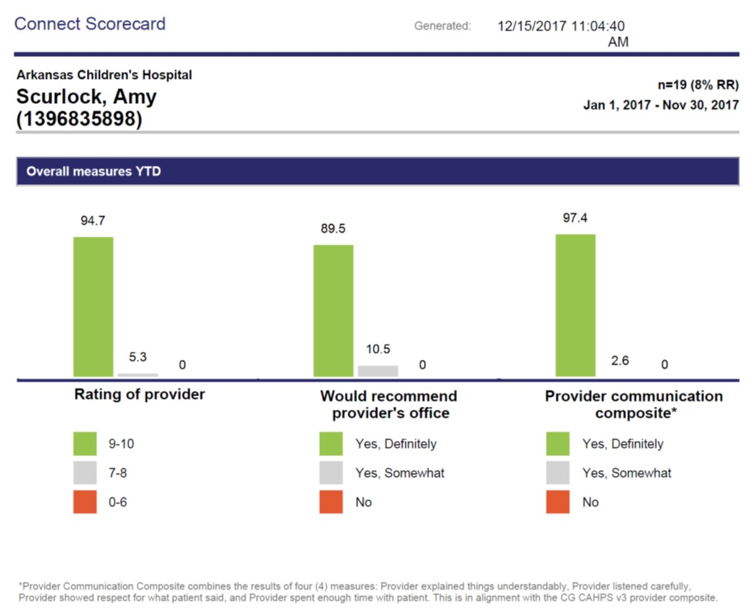

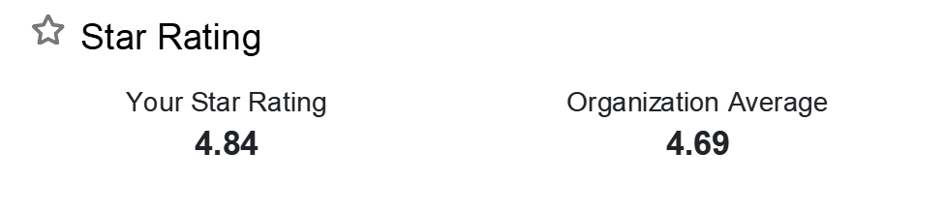

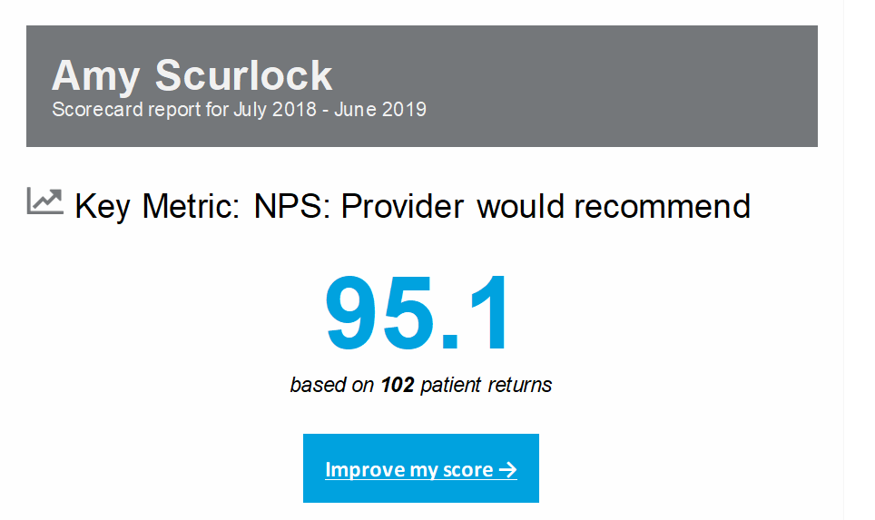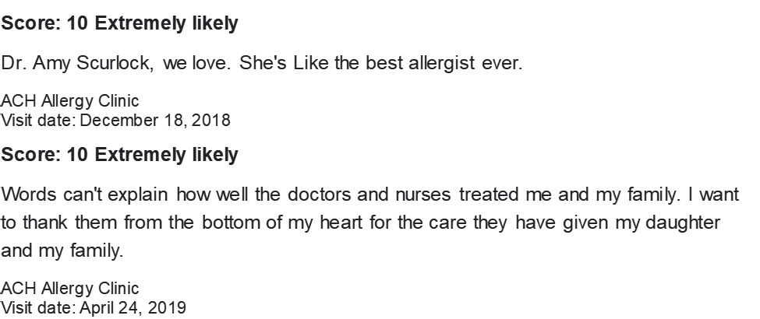

# Score: 10 Extremely likely

## This is the first time I have met Dr. **** and she was absolutely great, I've been to the clinic before and the nurses were always nice and helpful, I love her specialty nurse, Danielle she always breaks everything down and lets me understand what all these tests mean and how they're supposed to work. I would most definitely recommend Dr. **** and the Immunology clinic. They've been very helpful to me and my daughter. Thank you.

ACH Immunology Clinic Visit date: June 10, 2019

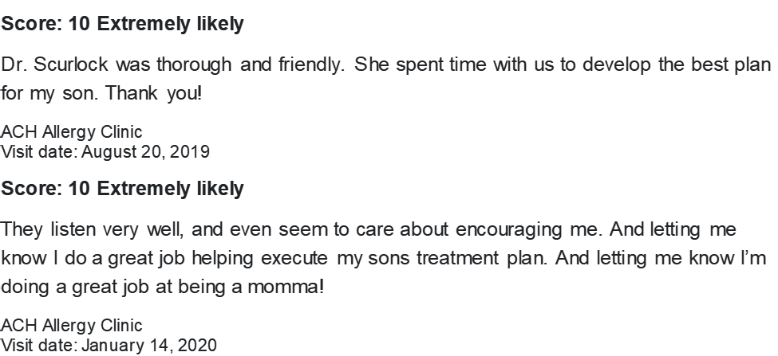

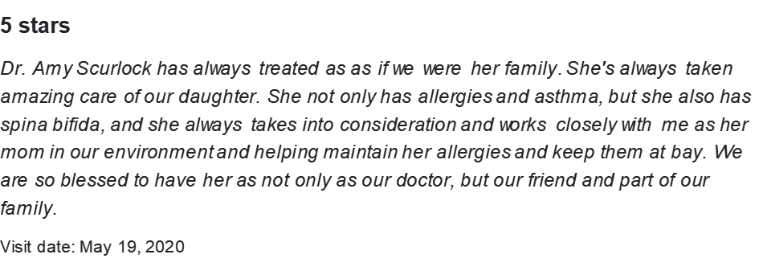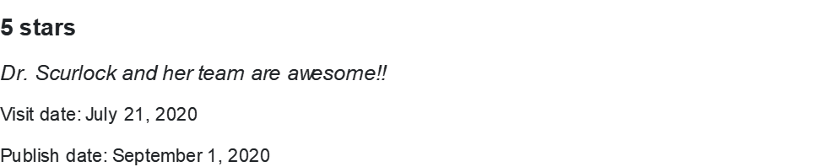



# Score: 10 Extremely likely

## Even though there was an emergency and our appointment was delayed, Dr. **** was thorough and didn't not rush our visit. We appreciate her knowledge and gentle spirit with our daughter.

ACH Immunology Clinic Visit date: April 5, 2021

