**Honors, Awards, and Professional Recognition**

**Professional Association Recognition**

2023 Arkansas Optometric Association Executive Committee- Secretary Treasurer

*Voted on by membership body at Spring Convention Membership Meeting*

2018 Arkansas Optometric Association Board of Directors. **See below.**

*Nominated by committee and voted on by membership body at Spring Convention Membership Meeting*

2018 LEAD Inaugural Leadership Class. **See below.**

Nominated by member and selected to participate in year-long events and classes

2018 Arkansas Young OD of the Year. **See below.**

Nominated by member and voted on by awards committee

**UAMS Recognition**

2020 Accolades-Dr. Westfall-Visionary Volunteers

<https://medicine.uams.edu/blog/students-receive-exams-glasses-from-uams-volunteers-on-mlk-day/>

2019 Accolades- Dr. Westfall- Gift of Sight. **See below.**

*MLK Day Free Pediatric Eye Clinic.*

2018 Team UAMS at Work. **See nomination below.**

*Nominated by UAMS employee. Selected by UAMS committee.*

2018 Dr. Westfall’s Accolades-Visionary Volunteers

<https://medicine.uams.edu/blog/students-receive-exams-glasses-from-uams-volunteers-on-mlk-day/>

2018 UAMS web story- College of Medicine Student Starts Lifetime Goal with Nonprofit

[https://medicine.uams.edu/blog/college-of-medicine-student-starts-lifetime-goal-with-nonprofit/](ttps://medicine.uams.edu/blog/college-of-medicine-student-starts-lifetime-goal-with-n)

2018 UAMS News- Fort Smith Man Regains Vision After Nearly Two Years in the Dark. **See below.**

[https://news.uams.edu/2018/08/03/fort-smith-man-regains-vision-after-nearly-two-years-in-the-dark/](ttps://news.uams.edu/2018/08/03/fort-smith-man-regains-vision-after-nearly-two-y)

2018 Faculty Recognition of Star Rating of 4.7 or Higher by the NRC Patient Satisfaction Survey. **See below.**

2018 Recognition of Completion of the MASTER evidence-based communication workshop. **See below.**

2017 UAMS Visions Magazine Feature- JEI Doctors Offer Life-Changing Results for Russellville Patient. **See PDF UAMS_visionsmagazine.**

2017 Lifesaver Award. **See below.**

*Nominated by UAMS staff and voted on by committee.*

**Community**

2022 Best of the Best Doctors Nomination for Best Optometrist

Arkansas Times

2020 AY’s Best Women in Health Care

2019 AY’s Best Healthcare Professionals

2019 KARK News Story- UAMS Helps Little Rock Students See Their Future

[https://www.kark.com/news/local-news/uams-helps-little-rock-students-see-their-future/1714246820/](ttps://www.kark.com/news/local-news/uams-helps-little-rock-students-see-their-f)

2018 KATV News Story- UAMS Doctors Help Man See Again

<https://katv.com/news/health/uams-doctors-help-man-see-again>

2018 Healthcare Journal of Little Rock- Hospital Rounds Write Up. **See PDF Healthcare Journal of Little Rock.**

2018 Community Partners Service Organization Nomination and Medical Student Award for ROOTS (Rural Ophthalmology and Optometry Treatment and Screening)

2017 Gamma Omicron Service Organization Speed Leading Speaker at Southern College of Optometry

*By invitation to successful, female leaders in optometry to participate in student event to share professional advice and stories of success.*

2017 Eclipse education on KATV, KARK, and Fox 16, and elementary schools. **See below.**

<https://katv.com/community/daybreak/uams-shows-how-to-watch-the-eclipse-safetly>

**Professional Association Recognition**

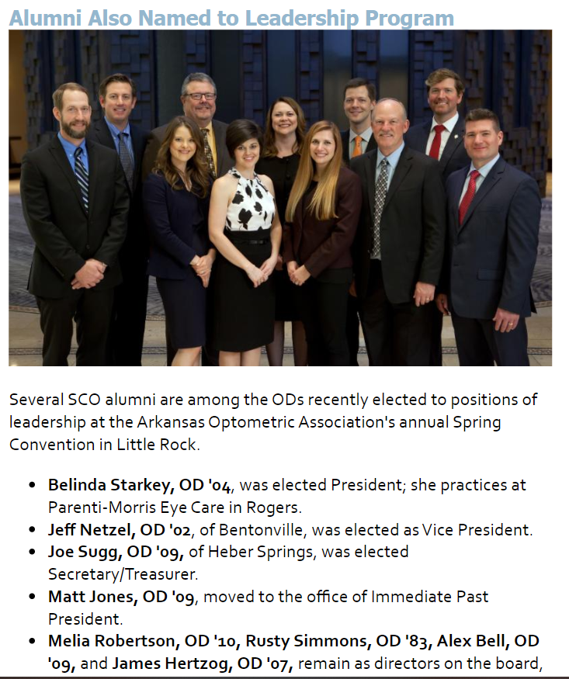

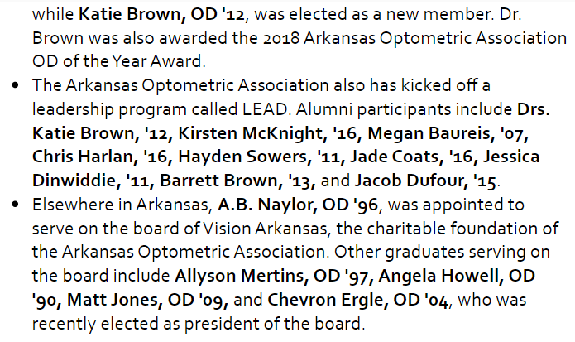

**Team UAMS at Work Nomination**

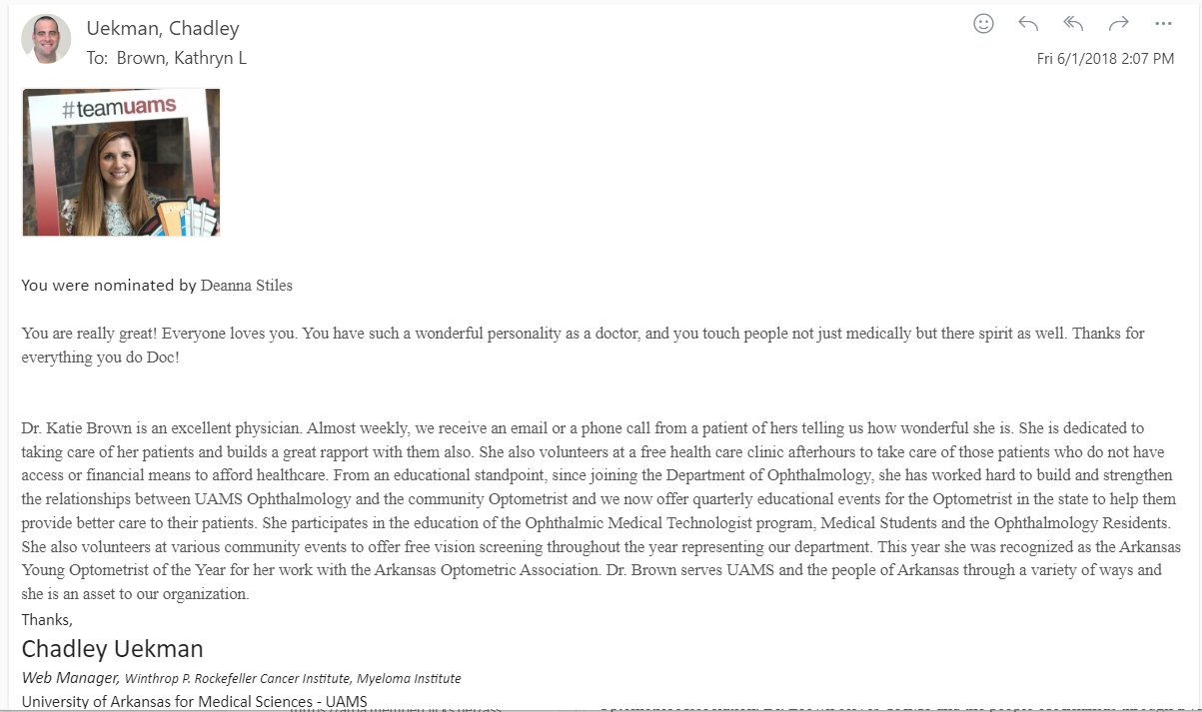

**2019 Accolade**

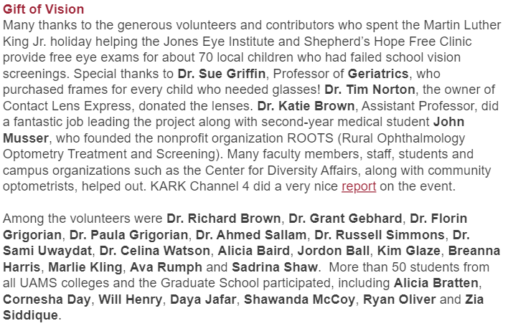

**Star Rating Recognition and MASTER completion**

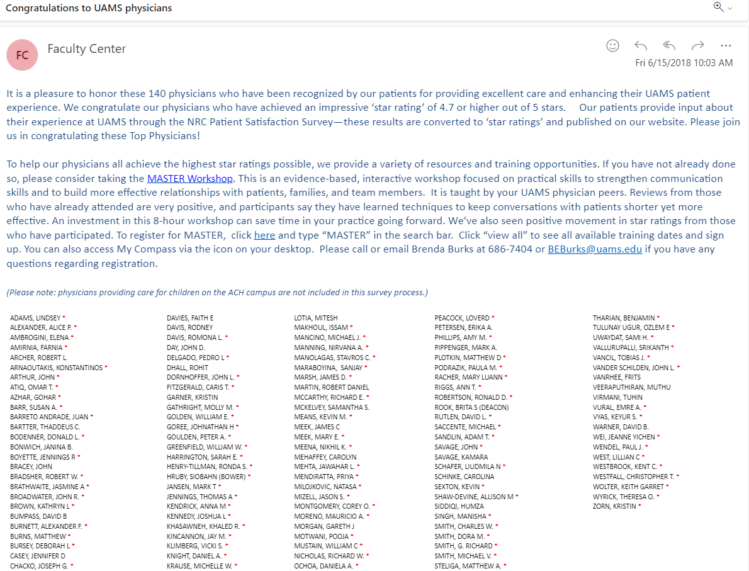

**2018 UAMS News**

**Lifesaver Award**

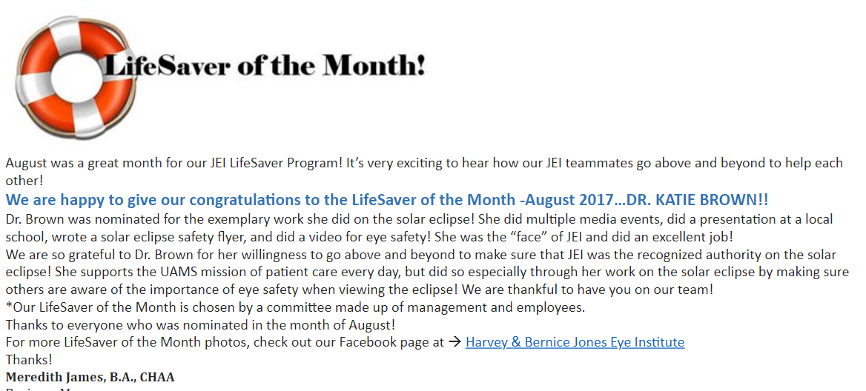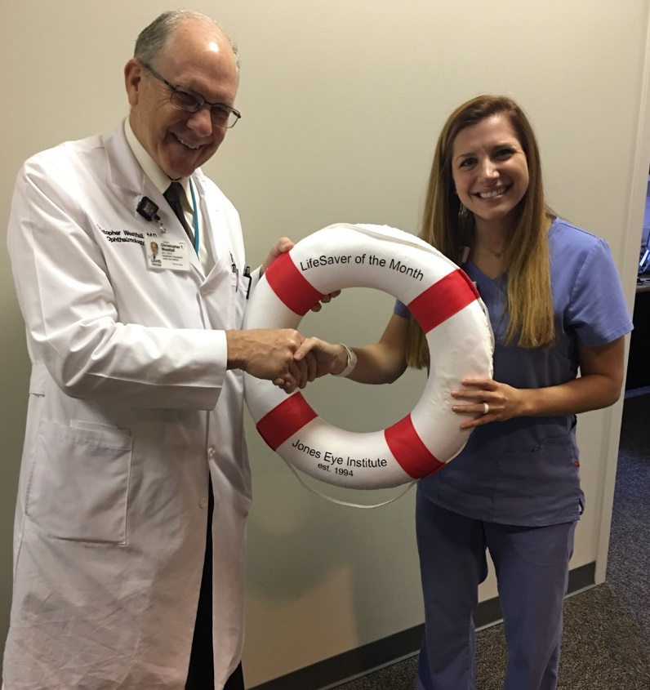

**Eclipse Education**

