Leadership/Administrative Activity FY14-FY23
Time and Effort: 9%

 ****, OD, MBA was appointed Instructor upon hiring in 2013 and was promoted to Assistant Professor in 2017 on the Clinical Attending Pathway at the University of Arkansas for Medical Sciences, College of Medicine (UAMS COM). She is applying for Associate Professor on this non-tenured track in September 2023.

Highlights

- Committee Appointments

  - UAMS Conflict of Interest (COI) Committee
    - 2018-Present
    - Review UAMS employees’ reported conflicts of interest as they pertain to awards, grant funding, and research
    - Review publications and presentations for adherence to COI management plans
    - Conduct expedited reviews as a primary or secondary reviewer
  - Ophthalmology Resident Interview and Selection Committee, Jones Eye Institute
    - 2016-Present
    - Interview and ranking of ophthalmology resident candidates
  - Community Relations Committee, Jones Eye Institute
    - 2015-Present
    - Organizing educational events for community doctors and patients
    - Public education regarding eye safety and solar eclipse in 2017
  - Optical Shop and Contact Lens Sales and Operations Committee
    - 2013-2019
    - Aided in the design and function of new optical shop constructed in 2015
    - Vetted glasses and contact lens manufacturers, distributers, and vendors for pricing and selection
    - Reviewed contact lens processes and pricing of medical lenses and soft lenses
    - Set and reviewed sales goals for contact lenses
  - Arkansas Optometric Association State Board Executive Committee
    - 2023-Present
    - Officer-Secretary Treasurer
  - Arkansas Optometric Association State Board of Directors
    - 2018-Present
    - Director 2018-2023

  - Arkansas Optometric Association Convention Committee
    - 2018-Present
    - Organize state-wide continuing medical education
  - Arkansas Optometric Association Awards Committee
    - 2018-Present
    - Review nominations for association-presented awards
  - Arkansas Optometric Association Membership Committee Chair
    - 2019-Present
    - Responsible for membership enrollment, engagement, and retention
    - Committee member since 2016
  - Arkansas Optometric Association Young Advocate Committee Chair
    - 2017-2021
    - Organize networking and social events for young optometrists in Arkansas who have been practicing 10 years or less
  - Arkansas Optometric Association Student Membership Chair
    - 2016-2020
    - Responsible for traveling to surrounding schools of optometry and engaging students in the state and national professional associations
  - Arkansas Optometric Association Public Relations Committee
    - 2014-2018
    - Educate the public on eye disease and the importance of primary eye care

- Administrative Services

  - Ophthalmology Case Conference/Grand Rounds Director, Jones Eye Institute
    - 2016-Present
    - Schedule and organize resident and faculty speakers, guest lecturers, and visiting professors to provide continuing medical education
    - Conduct review of participant surveys and process improvement with regards to education quality
  - Ophthalmology Resident Optics Course Developer and Director, Jones Eye Institute
    - 2016-Present
    - Responsible for creating the curriculum for didactic and clinical optics education
    - Conduct individual resident evaluations and grading of end of course examinations
  - Ophthalmology Resident Contact Lens Course Developer and Director, Jones Eye Institute
    - 2016-Present
    - Responsible for creating the curriculum for didactic and clinical contact lens education
    - Conduct individual resident evaluations and grading of end of course examinations
  - Optometric Education Developer and Coordinator, Jones Eye Institute
    - 2016-Present
    - Responsible for organizing educational events with faculty speakers at UAMS for community optometrists
  - UAMS Jones Eye Institute Rapid Fire Session Coordinator at Arkansas Optometric Spring Convention
    - 2016-Present
    - Organize faculty involvement and lecturers to provide continuing medical education to Doctors of Optometry at state convention
    - Introduction of faculty and case presentations during sessions
  - Contact Lens Ordering Manager
    - 2014-Present
    - Custom ordering of patient prosthetic lenses, rigid gas permeable lenses, hybrid lenses, and custom soft.
    - Review of soft lens pricing, sales goals, and negotiations with distributors and manufacturers.
    - Compliance review of state and federal contact lens law

- Community Service

  - ROOTS- Rural Ophthalmology Optometry Treatment and Screening
    - 2018-Present
    - Founding board member of non-profit organization aimed at providing rural and/or underserved populations with access to quality eye care
  - Marshallese Gift of Sight Cataractathon
    - 2021-Present
    - Provide free cataract surgery to Marshallese population from Northwest Arkansas
  - Shepherd’s Hope Community Clinic Volunteer
    - 2013-Present
    - Free, comprehensive eye exams, glaucoma evaluation and treatment, diabetic eye exams, and glasses fittings to those in the community who demonstrate financial need
  - MLK Free Eye Exam Day Coordinator and Volunteer
    - 2018-2020
    - Free, comprehensive eye exams and glasses for children who failed school vision screenings within the Little Rock School District
  - Sight Savers Clinic Volunteer
    - 2013-2014
    - Free, comprehensive eye exams and glasses

  - Be My Eyes Organization
    - 2020-Present
    - Social media-based volunteer to take video calls from blind individuals to help them with activities of daily living
  - Remote Area Medical Volunteer
    - 2009 & 2010
    - Comprehensive exams in remote areas of the country and world
  - Stop Hunger now
    - 2010 & 2011
    - Assemble and pack meals for distribution worldwide

- Memberships in Professional Organizations

  - American Optometric Association – 2008-Present
  - Arkansas Optometric Association – 2010-Present
  - Beta Gamma Sigma: Academic Business Honors Organization – 2020-2022
  - Lion’s Club – 2010-Present
  - Beta Sigma Kappa: Academic Optometry Honors Organization – 2009-2012

Detailed Description of Administrative Duties

Committee Work
Dr.  is very involved in leadership both within UAMS and outside of UAMS in the community. Over the last 10 years, Dr.  has been involved in numerous committees all while maintaining a busy clinic and teaching schedule. Committee work is further broken down and detailed below.

UAMS

Dr.  has been very involved with the Conflict of Interest (COI) Committee since 2020 after accepting an invitation to serve on the committee as a director by a previous Vice Chancellor. This committee meets monthly to discuss in-depth reviews of UAMS employees and their disclosed conflicts as they pertain to relationships with other employees, students, and outside entities. Each month, prior to the meeting, assignments are sent to the committee members along with an agenda for discussion. These assignments detail which employees need to be reviewed and discussed during the meeting, along with which committee member will be the primary reviewer. The primary reviewer is responsible for taking lead and investigating if the employee is compliant with, not only their disclosures, but also with reporting their disclosures during lectures, publications, and research as detailed by the employee’s individual management plan. Dr.  also participates in expedited reviews in which award money is granted necessitating a review to complete the award processing. These expedited reviews must happen between monthly meetings, so that there is not a delay in making funds available for use by the institution. Dr.  has also participated in subcommittees in which more discussion and research is needed regarding employees with questionable relationships or reporting. These subcommittees meet separately to fully investigate more complicated employee issues. The subcommittee then reports to the larger COI committee during monthly meetings with recommendations regarding individual management plan updates and employee compliance status. The reports are also sent to the appropriate department chairs and deans for communication and disciplinary purposes.

Jones Eye Institute

Annually, the Department of Ophthalmology conducts interviews for incoming ophthalmology resident positions. The department currently accepts 4 new residents per year into a 4-year-long residency. The department receives 300+ applications of which 60 are selected to interview in-person. These interviews are conducted over the course of several days, and a departmental ranking meeting is held to review and discuss the applicants. Dr.  has been participating in this process on the Ophthalmology Interview and Selection Committee since 2016.

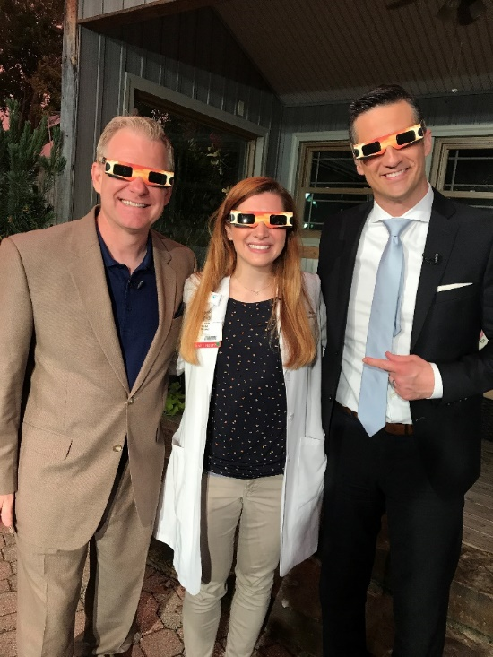
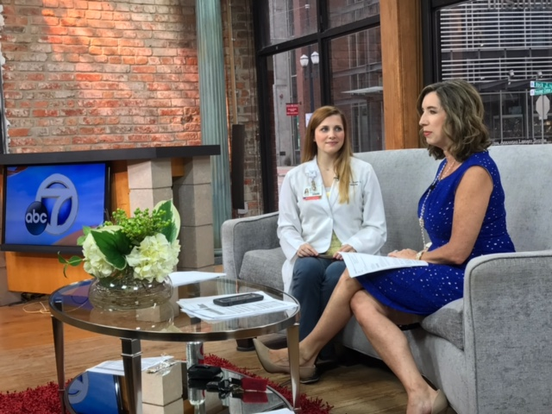
The relationship that UAMS Jones Eye Institute has with its patients and community doctors is a critical component to the department’s overall success. Dr.  has been an integral part of nurturing these relationships since her employment in 2013. Upon hiring, Dr.  coordinated with the UAMS Marketing Department to record a series of educational patient videos regarding eye exams, ophthalmology services, and common eye-related problems. In 2015, the Jones Eye Institute formed a Public Relations Committee on which Dr.  happily volunteered to serve. This committee is dedicated to educating and interacting with the public and community doctors. Some of the highlights of the committee’s projects include a diabetic and eye health cooking seminar, 2017 Eclipse education, and physician education and live patient fitting lab involving specialty contact lenses. Please See Attached report generated by the UAMS marketing team regarding Dr. ****’s outreach efforts, and school and news appearances during the 2017 Eclipse. This natural phenomenon was a wonderful opportunity to educate the public and gain public traction as a trusted resource for eye care in the state. Some highlights of those outreach efforts are:
THV11 News Appearance with Tom Brannon
KATV News Appearance
- 6 media appearances and public-school visits by Dr. 
- UAMShealth and Jones Eye Institute web traffic increase of 195% and Google listing up 35%
- UAMS and Jones Eye reached 68,00+
- UAMS video alone reached 27,000+
- KTHV partnership/sponsorship made 954,024 impressions

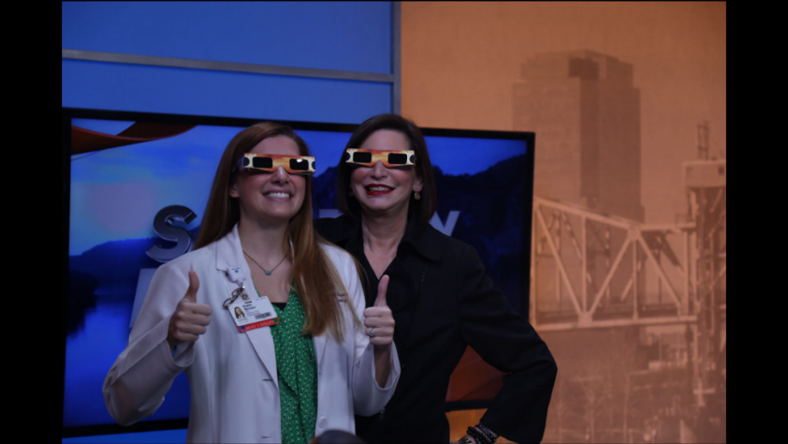

KARK News Appearance

Upon hiring in 2013, Dr.  has taken on the task of revamping and organizing the contact lens department. She has also played an active role in the optical shop operations. In 2015, a complete redesign and relocation of the optical shop was undertaken by the department. At that time a committee was formed, the Optical Shop and Contact Lens Sales and Operations Committee, on which Dr.  was asked to serve. This committee had input regarding the design and function of the new space along with rebranding of the optical shop, addition of new vendors, and vetting new labs in which to conduct business. New sales goals were set and evaluated monthly to ensure that the new and improved optical was financially productive. Dr.  is currently evaluating the feasibility of adding a finishing lab complete with edger (lens cutter) to the optical shop, so that same-day glasses can be produced for UAMS patients. This would be an amazing convenience and service to offer to our patients and could help increase revenue for the Jones Eye Optical Shop and Ophthalmology Department.

Arkansas Optometric Association

Dr.  is heavily involved in her state professional association and affiliated national association. Dr.  is the current Secretary-Treasurer of the Arkansas Optometric Association and serves on the Executive Committee as an officer. She has served on the Board of Directors since 2018 when she was nominated and voted into office by the membership body, which is made up of Arkansas optometrists. Dr.  is slated to become the Arkansas Optometric Association President in the year 2026. The association manages a multimillion-dollar budget and offers benefits of advocacy, education, private practice benefits, patient education material, coding and billing support, technician and practice management resources, and business and liability insurance. Dr.  has served on several committees within the association including the Convention Committee, the Awards Committee, the Young Advocate Committee, the Public Relations Committee, the Student Membership Committee, and the Membership Committee. She has chaired both the Student Membership Committee and practicing physician Membership Committee. While leading those committees Dr.  had 100% of Arkansas students enrolled as members in the association and currently has 83% of optometrists in Arkansas involved in active membership in the state association. This summer (2023), at the American Optometric Association (AOA) meeting in Washington, D.C., the Arkansas Optometric Association received an award and recognition during the AOA House of Delegates Meeting for membership market share growth. This is the first year that this award has been given to the Arkansas Optometric Association and is a direct reflection of Dr. ****’s efforts since chairing the committee in 2019. Dr. ****’s service, commitment, and accolades demonstrate her dedication to her professional association.

Administrative Duties

Dr.  enjoys the other opportunities offered at UAMS to expand her administrative reach and leadership. She never turns down an opportunity to grow in this area of her career and is always happy to revamp a curriculum or organize educational events during her administrative time. Dr.  was given the task of managing and scheduling the Ophthalmology Case Conference Series in 2016 and is still the Director of this weekly, continuing medical education event held every Thursday at 5pm. Please See Attached Case Conference Schedule as an example. Attendees include community ophthalmologists and optometrists, and physicians from the VA and Arkansas Children’s Hospital. The schedule of topics and speakers is distributed every 6 months with plenty of time for lecturers to prepare. Dr.  is responsible for organizing the resident speakers, the subspecialty topic (cornea, neuro, retina, glaucoma, etc.), and the attending physician overseer. This schedule is very fluid due to the need to review interesting cases that present in-clinic or on-call that serve as valuable teaching points. Therefore, the schedule must be managed very closely on a weekly basis. Visiting professors are also invited in this time slot, and Dr.  helps to spearhead communication and organization with these doctors, many of whom travel from out of state to give these educational talks. As with all continuing medical education offered for credit, process reviews and participant surveys are collected to ensure that educational needs are being met. Dr.  helps to process and interpret the survey responses to keep the educational series functioning at the highest quality possible.

Since 2016, Dr.  was tasked by Dr. Richard Harper, the Ophthalmology Resident Director, to create an optics and contact lens curriculum for the ophthalmology residents and to become the Optics and Contact Lens Course Developer and Director. This was a large task as the optics section is one of 13 sections on which the ophthalmology residents are tested upon nationally. Other sections include general medicine, ocular pathology, retina and vitreous, glaucoma, along with others. At the time, there were a handful of lectures that were given by Dr. Harper that covered basic optics with no contact lens or low vision education. Dr.  created a morning conference schedule and lecture series that is given on Monday, Tuesday, and Friday for 5-6 weeks during March, which has in-depth geometric, physical, and contact lens optics along with interactive polling of the residents of optics-related problems for review. Please See Attachment with Optics Morning Conference Schedule. Since COVID-19, Dr.  has worked diligently and successfully recorded all the optics and contact lens lectures and made them available for the residents to watch at any time. At the end of the lecture series each year, a written multiple-choice and short answer test is given and graded. Dr.  also created the clinical rotation schedule for the residents that includes nightly reading material, worksheets, and Power Point lectures that are more geared toward clinically-relevant optics and contact lens topics. Each resident goes through a 4-week clinical rotation as a PGY-2 in which 2 weeks are spent on general ophthalmology, refraction, and retinoscopy, and 2 weeks are focused on contact lens fittings to include soft, rigid, and prosthetic lenses. Please See Attachment with Optics and Contact Lens Resident Rotation Schedules.

Dr.  enjoys bringing community and academic doctors together in the spirit of learning, education, and comradery. The more well-connected the physicians, the better off the patients of Arkansas are who have eye care needs that span subspecialties. This is why Dr.  has made it a mission of hers to merge the worlds of private practice and academia through educational events. Dr.  is the driving force behind the pre-COVID educational series aimed at connecting the physicians of Jones Eye Institute to the community optometrists. See the below community events that Dr.  organized as the Optometric Education Developer and Coordinator.

Year | Title of Educational Series | Speakers
2016 | OCT for the Primary Eye Care Provider |  KL,  M, Uwaydat S, Sallam A, Chacko J, Morshedi G
2017 | Common Corneal Disorders/Infections Tx and Mx |  KL, Warner D, Ali T, Lemmons J
2017 | Scleral Lens Live Patient Fitting Lab/Lecture |  KL, Lant M
2019 | OCT Open Forum Discussion |  KL, Lee C, Warner D, Phillips P
2019 | Diabetes and the Eye |  KL, Uwaydat S, Vines H
2019 | Diabetes and the Anterior Segment |  KL, Uwaydat S, Sallam A, Grigorian P, Chancellor J

Dr.  also enjoys cultivating relationships with primary eye care doctors in the state through her efforts as the UAMS Jones Eye Institute Rapid Fire Session Coordinator at the Arkansas Optometric Spring Convention. Hundreds of optometrists and their staff attend this statewide, yearly educational convention. Dr.  has secured a 4-hour lecture spot for UAMS at this convention every year since 2016 with a virtual presence in 2020 due to the COVID-19 pandemic. Dr.  proudly introduces and lectures alongside her colleagues during this event and presents interesting patient cases throughout the lecture series. Since the return of in-person meetings in 2021, the UAMS lecture slot has been gaining popularity, and now, more than half of the optometrists in the state are in attendance, largely due to Dr. ****’s continued efforts.

Community Service

Dr.  is passionate about community service and health equity. She believes that everyone should have access to quality eye and health care. This is why Dr.  spends a significant amount of her free time volunteering. The free clinics that she has volunteered at include Remote Area Medical, Sight Savers, MLK Free Eye Exam Day, Marshallese Gift of Sight Cataractathon, and Shepherd’s Hope Community Clinic. The clinic that she is the most involved with presently is Shepherd’s Hope Community Clinic. She has been a volunteer at this clinic since 2013 and has been performing free diabetic, glaucoma, and glasses exams at the clinic’s bi-monthly eye clinic. The neighborhoods surrounding the clinic are in a dense Hispanic area. Most of the patients who demonstrate financial need, thereby qualifying them for medical services, speak Spanish. Dr.  has enjoyed learning from the interpreters how to conduct an eye exam in Spanish, and this has carried over into her work life at UAMS to benefit Spanish-speaking patients at the Jones Eye Institute. In 2021, Dr. ****, assuming the role of primary investigator, and a team of researchers from UAMS were selected to participate in a Community Based Research Project to collaborate with Shepherd’s Hope Medical Clinic to implement electronic health records and telehealth. The group was to study the implementation of EHR and telehealth in a community care setting and to investigate barriers to care. This project is still awaiting funding but is a perfect example of the benefits of the partnership and collaboration of academia and community clinics.

Dr.  is a founding board member of a non-profit organization, ROOTS, Rural Ophthalmology Treatment and Screening. The organization was founded in 2018 and has a mission of serving rural or underserved populations and providing access to quality eye care. This group has provided glaucoma and vision screenings at large events in Little Rock, such as the Back to School Bash at the Clinton Library. An active project and goal of the group is to obtain funding for a mobile eye unit, equipped with 2 vision lanes and retina imaging equipment. Through Dr. ****’s connections, ROOTS is a proud partner with UAMS Jones Eye Institute and has hosted the MLK Free Eye Exam Day 2 out of the 3 times that the event took place pre-COVID in 2019 and 2020. During this event, in coordination with local school nurses and volunteers from 6 different colleges across the UAMS campus, over 200 children who failed their vision screenings were seen on MLK Day and provided a comprehensive exam and a pair of glasses. Please See Attachment or follow link provided here. Read more about it here

