COM Promotion and Tenure System
https://PromotionTenure.uams.edu

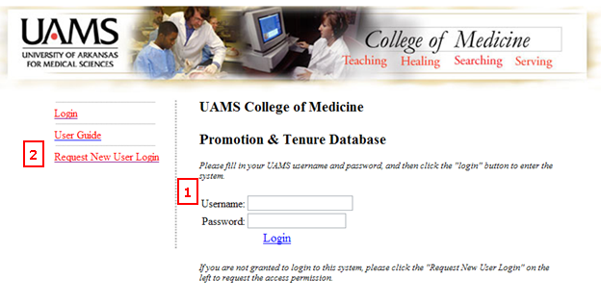
- If you have already requested a login, simply type in your UAMS user name and password in the space provided.
- If accessing the system for the first time, click ‘Request New User Access’.
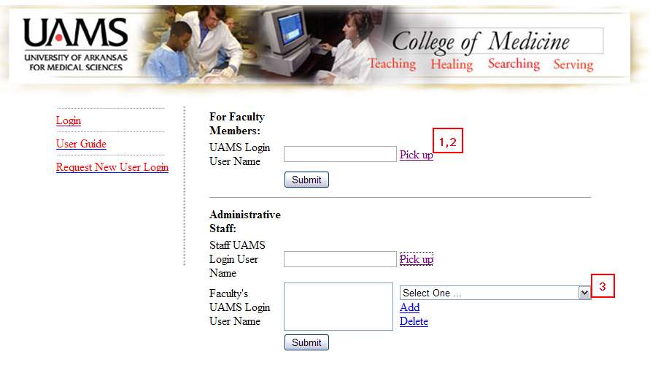
- For faculty members requesting new login, click ‘Pick up’.
- ‘Pick up’ will open a pop-up box. Type in the last name and/or first name and select from the list provided.
- For Administrative staff requesting new login, click ‘Pick up’ for your login and select your faculty member’s name from the list and click ‘Add’. You can select multiple faculty members.

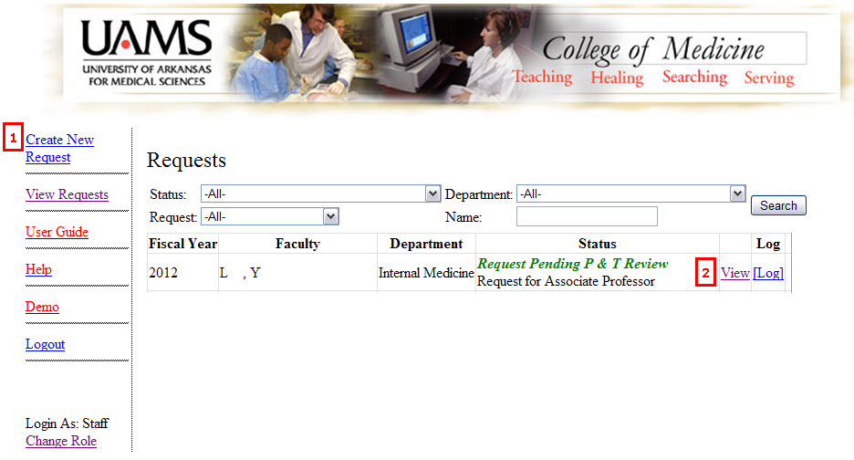
- The first time you login, you will need to ‘Create New Request’
- After the request is created, at login, you will be able to view your created requests here.
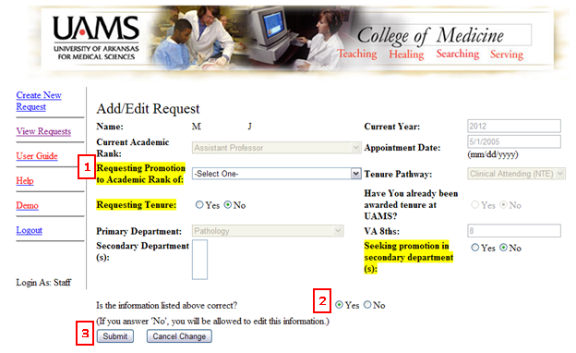
Once you click ‘Create New Request’, this is the screen that will be generated. All of the information in the greyed out areas are imported from FacFacts. Please review this information carefully.
- Fill in the highlighted fields.
- If information from FacFacts is correct, mark ‘yes’. If information from FacFacts is incorrect, mark ‘No’. You will have the opportunity to edit this on the next screen.
- Hit ‘submit’.

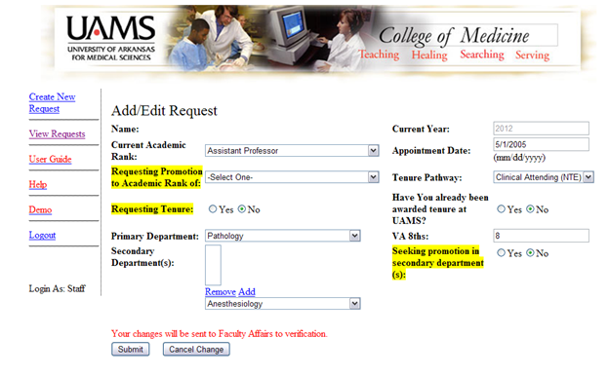
If you answered ‘no’ on the previous screen regarding FacFacts information, you will be prompted to edit fields in this screen. Edit as necessary and hit ‘submit’. Upon submission, an email will be sent to the Faculty Affairs office for verification. You will not be able to continue until the changes have been verified. At that time, you will receive an email to inform you that you can continue.

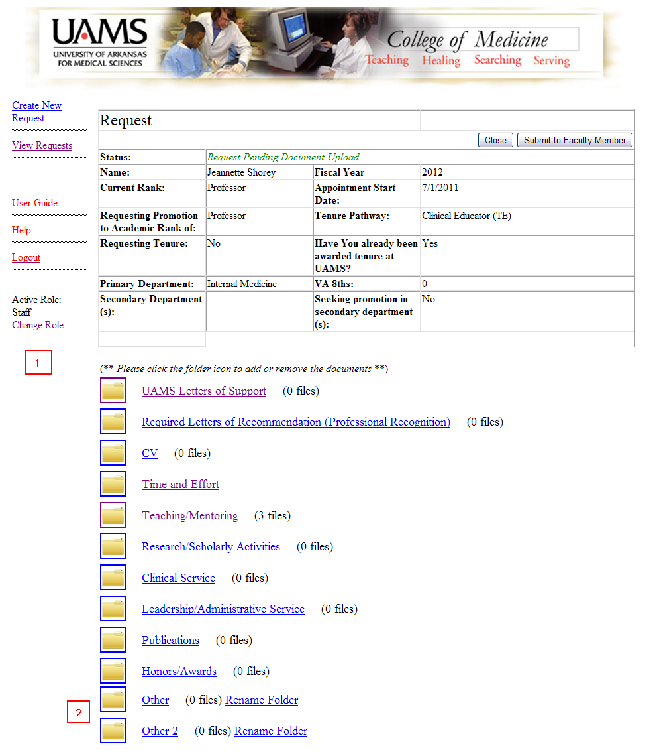
At this point, you are ready to upload documents into this request.
- Click on the appropriate folder where you want to upload documents.
- The ‘Other’ folders can be renamed to suit your needs. Click ‘Rename Folder’ and type in the name of the folder you wish to create.

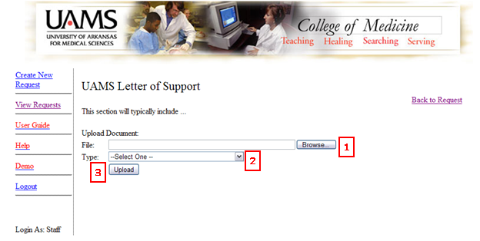
All folders, except for Time and Effort, will look like the screen shot above.
- To upload a document, click the ‘Browse’ button. This will allow you to search for the document saved on your computer.
- Select the document type from this drop-down box.
- Click ‘Upload’. The document will appear below this button. (See next screen image below.)
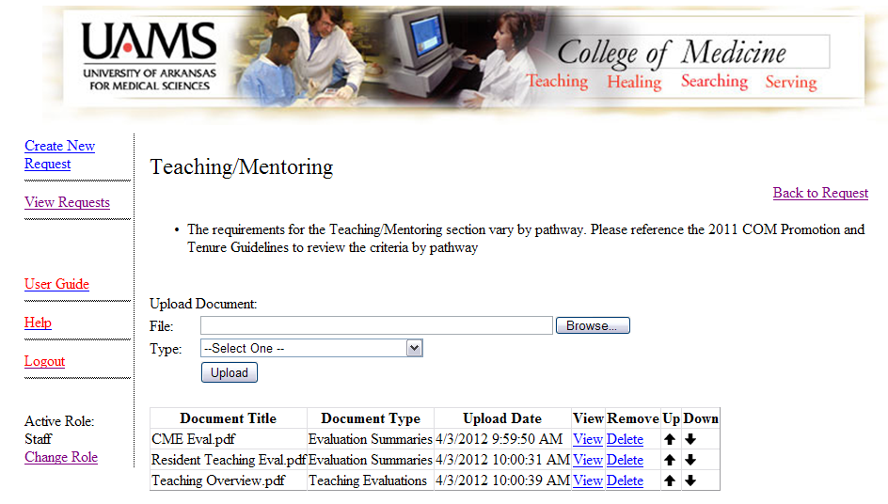
This image shows the documents that have been uploaded for this folder. You can use the arrows next to the documents to order these within the folder.

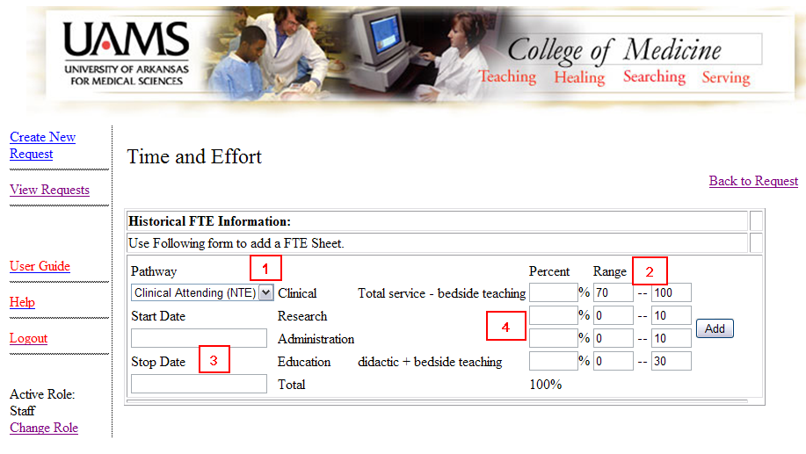
- For the Time and Effort screen, select the appropriate pathway from the drop down box.
- The corresponding ranges will auto-populate.
- Enter the start and stop dates for the time period that you are entering.
- Enter the appropriate percentages, and click ‘Add’.

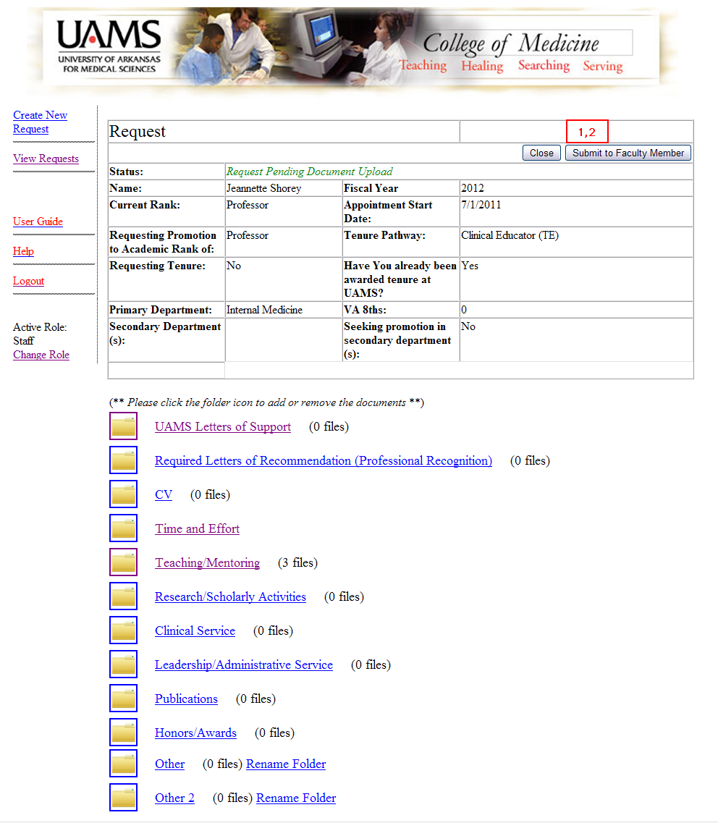

- Once all the documents have been uploaded, click ‘Submit to Faculty Member’. An email will be sent to the faculty member letting him/her know that the request is ready for review.
- The faculty member’s screen will look exactly like this one, except the button at the top will say ‘Submit to Faculty Affairs’. When the request is complete, click this button to submit the Promotion and Tenure request for review by the College.

